Good Morning 5/6B – Year 6 children!
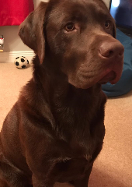
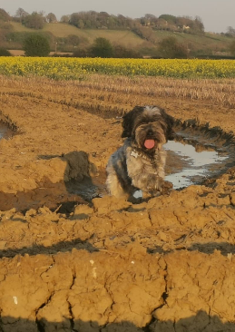
I hope that you all enjoyed last week’s tasks and I am looking forward to seeing your photos of everyday objects to see if I can guess any of them. It was really marvellous to hear your voices over the phone this week and myself, Mrs Mulhall and Mrs Hildred are all missing seeing your lovely faces everyday – hopefully it won’t be too much longer before we are back at school. It has been lovely to hear what you have been doing to keep yourselves busy at home. I hope Isaac’s been enjoying using his Basketball hoop that he made; Hattie created some amazing artwork; Charlie has sent a clip of him completing lots of activities; Aurora has been arm-knitting; and lots of you have been baking too – delicious! I’ve heard about the diaries some of you have been keeping; recording this time so that you can remember about when the world stopped. I’ve seen more music lessons taking place virtually on Zoom too. Amazing stuff everyone! The wonderful news is that every single one of you is healthy.
The weather hasn’t been as nice this week but the silver lining is that I have been able to get on with some painting and decorating jobs inside. Bailey, my naughty dog, has “helped” me by walking through the paint tray…leaving a trail of footprints behind her!! What a cheeky monkey she is! Mrs Mulhalll has been busy sticking pictures into the Year 6’s books and Harley, the dog, has been helping her too.
It’s time to set you some more work! This is Week 4 of the Summer Term and normally you would be doing lots of tests for SATs week! Unfortunately you won’t have the chance due to Covid-19, the nasty virus that is keeping us all at home. There are no tests for you to do, but I hope you enjoy the tasks I have set. Remember, the work here is for you to access, but every home is different and all your situations at home may be different too. Try not to worry if you can’t concentrate or complete all of the tasks. They are just ideas for you to do to continue your learning; we understand if you are not able to do some of them – do the best you can, as always! I can see lots of you have been making a big effort on Mathletics – some amazing scores once again! Well done, keep up the good work.
It is great to hear so many of you are working your way through the pile of booklets that were sent home in a pack. Well done – we are very proud of how hard you are working.
If you are wanting a booklet to complete with lots of maths, reading and SPaG questions to keep you going, then click on the following link. Don’t worry about whether you have a printer, you could just write your answers on some paper instead. https://digify.com/a/#/view/2f83f984472146538c85110cce26f82f and here are the answers (TOP SECRET): https://digify.com/a/#/view/2d49345d6dea409884406f1c653b74e0
Remember that there are teachers in school every day and that if you need help with anything or if you have any questions about the work that I have set, then you can ring the school office on 01400 659001. Even if I am not in school that day, I will be sent a message.
Keep safe, love from
Mrs Birchenall, Mrs Mulhall and Mrs Hildred

Maths  Please continue to complete your daily maths lesson, using the White Rose resources from the website. There may or may not be a sheet available each day this week (they keep changing their minds!), but if not, just have a go at the questions on the video, on a piece of paper. Remember to also follow the links to BBC Bitesize for even more practise.  You can find your lessons here: https://whiterosemaths.com/homelearning/year-6/ Please move onto the section labelled ‘Summer Term Week 4 w/c 11th May’. The videos are also available on Facebook, if the website is overloaded.  Of course, I’ll continue to set tasks on Mathletics, but only do these if you have spare time!  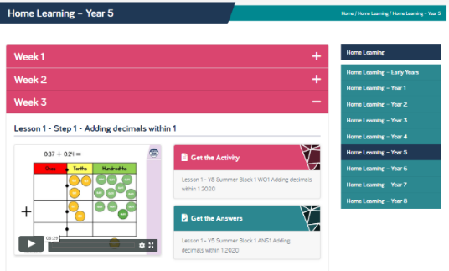  Want an extra challenge? Have a go at the puzzles below – they should get your brain working! Perhaps you could phone a friend and compare answers? See if you can challenge your mum and dad too? | Science – Earth and Space  I hope you enjoyed your star gazing and managed to spot some of the constellations from your sheet.  This week, we’re learning about why we have night and day. Have a look at BBC Bitesize for a great explanation: https://www.bbc.co.uk/bitesize/clips/zkynvcw  There’s also a simple set of instructions for an activity to help you to understand, at the bottom of this document.  If it’s a sunny day, you can put all this to the test. Go out nice and early and put a stick into the ground. Where does its shadow lie? You could mark the end of the shadow with a stone. Go out at lunchtime and see what’s happened. Repeat your observation later in the afternoon. This is how a sundial works and here are some instructions to help you make your own: https://www.youtube.com/watch?v=Gxo8orZ1X7g | Literacy  I think it is time for a piece of creative writing. I would like you to imagine you are an author who has been asked to write a story set in space. Before you write your story, like all successful authors, you will need to make a plan.  Monday: think about your setting. Is it futuristic or in space? Close your eyes and imagine what you can see. Think about the detail, what would make it realistic to the reader? What would really grab their attention? Once you have decided on your setting, sketch it and colour it in.  Tuesday: decide on your main character or creature from another world…or time…or even someone travelling there. Really think about your character and their personality traits, how they would speak, what vocabulary they would use, their appearance. Sketch them and then colour them in.  Wednesday: decide on a dilemma or problem to be solved. Then, after a break where you can do something entirely different, come back to your writing and decide how the dilemma or problem is solved by your character.  Thursday: write your first draft of the story. Remember: dialogue to create atmosphere and to move the action along; show the character’s feelings to build tension in your story (his heart thumped with trepidation…or…her breathing quickened with fear); short, snappy sentences for effect; and imaginary, scientific vocabulary (robotron, galatco-shoes).  Friday: read your story to your grandparents (or another relative of your choosing of course!) over a videocall/skype etc.  Enjoy your stories!
PE
Keep joining in with Joe Wicks (and his lovely wife Rosie) each morning. It will make you feel better and ready for the day ahead. I hope you have been having fun having a go at the challenges Mrs Owen has put on Parentmail to keep you fit at home.

If you are looking for fun, easy, space-themed activities to complete, then Mission X is the right place to be. The challenge is now open for families. You can join the Walk to the Moon challenge and complete other Mission X activities to help the characters Luna and Leo walk to the moon. Every effort counts. For more information, visit: https://www.stem.org.uk/missionx and click on CHALLENGE to register (please ask mums and dads to do this bit for you).

History
This week, we zoom forwards to the 20th Century. I’d like you to find out about the History of Computing, which is an innovation that changed our lives forever.

You might like to watch: https://www.bbc.co.uk/bitesize/topics/zbhgjxs/articles/ztrq7ty

If you scroll down to the bottom of that webpage, you’ll find some other interesting activities to do with computers too.

I won’t ask you to write anything for History this week, as you’ll be busy with your fantastic story!
 | German  I hope you have been enjoying practising your German using Duo Lingo. I must say I am enjoying my German and when I chatted to you all, lots of you said you were enjoying it too.  - Keep practising – it’s quite fun https://www.duolingo.com/ | Reading  I hope you are enjoying your super reading dens. If it is nice weather this week, why not create a relaxing reading space in the garden? Keep practising reading out loud, even if it is just to the bees  If you are running out of books to read, then try the following:  - Remember David Walliams is reading every day at 11am https://www.worldofdavidwalliams.com/elevenses/  - Or on Audible, all of their stories are free at the moment. Just choose one and listen. https://stories.audible.com/start-listen  - Or why not try Oxford Owl’s free online library https://www.oxfordowl.co.uk/for-home/find-a-book/library-page which has lots of your favourites from school!  Just for Fun!!!  Juggle  Learn to juggle! There are lots of tips online, try it with something soft at first and preferably in the garden so you don’t break anything.  Design a paper aeroplane  Challenge your siblings/parents to a paper aeroplane contest – whose aeroplane can travel the greatest distance? Stick a piece of paper/newspaper/wrapping paper across the hall. Cut large circles out of it. Can you get the planes to fly through the circles? Who is the best?  Mini Ice Hockey  You'll need: a baking tray, water, post-it notes, spoons and a button or bottle lid – and probably best to go in the garden for this!  Freeze a layer of water in a baking tray to create your ice rink and stick a post-it note at either end of the tray to mark the goals. Use spoons as your hockey sticks and try to hit your button/lid puck against the post-it note on the other side of the tray.
Just because…
Flex your writing muscles and write a letter to older relatives or neighbours who might be feeling a little lonely right now. Let them know you're thinking of them.

