Numeracy  Keep doing the home learning lesson each day on the White Rose website for year 3. Remember to do Mathletics activities too.  Try Education City or Prodigy for fun games and Times Table Rockstars. For fun reasoning activities try-  https://nrich.maths.org/  Remember you need to know 2x, 5x, 10x, 3x, 4x and 8x table and division facts out of order. Can you make cards to help you practise? | Literacy  Try to read more books and then do a book review.  Practise spelling another ten key words each week.  Can you improve VCOP with the activities below?  If you want to do more writing, try to write the story of a film you have seen or information writing about a documentary. | PE  Keep practising throwing and catching in lots of different ways. Challenge yourself to get to 20 then 30 without dropping it. Can you play simple games of tennis, cricket or rounders? You could practise against a wall or with a balloon, soft toy or beanbag if you are inside.  Remember you could try Joe Wicks to energise you every morning or Cosmic yoga or Just Dance.  Can you invent fun obstacle courses inside and outside?  Hopefully you are getting out everyday for a walk, scooter or bike ride. How many different trees can you spot each day?
Science  Try to identify different trees on your walks. Are they evergreen or deciduous?  Do the activities on Education City.  (Science Year 3 Plants)  “Best laid plants”, “Granny’s garden” and “Seed feed”  Now try to present the life cycle of a plant from seed formation to growth, pollination and dispersal. Use labelled diagrams. | 3CO  Well done for working hard so far! We have enjoyed seeing your photos on emails.  This work is for the weeks  11th to 22nd May. | History  Our topic is local history, including RAF Cranwell.  Research about the Wright brothers and RAF planes through history. Watch Youtube videos or use websites.  Present your information on a poster or PowerPoint.  Can you interview friends/relatives about planes especially World war 2? Did you find out about VE day?  https://kids.kiddle.co/Wright_brothers  https://www.rafmuseum.org.uk/documents/Cosford/Educational-Visits/Key-stage-2/Science-of-Flight-Compilation.pdf
RE  Now look at the Hindu Creation story. Summarise the story by writing sentences and drawing pictures. Use the PowerPoint on twinkl to help you. How is it different/similar to the Christian story?  https://www.twinkl.co.uk/resource/t2-r-178-hindu-creation-story-powerpoint  Can you make a card about our beautiful world and send it to your grandparents or a family friend? | Home learning for 3CO  Each day try to do an hour’s exercise, some numeracy and some literacy or another subject.  However, imaginative play, baking, art work, playing card and board games (anything not electronic!) is just as important to keep happy and healthy.  Just do the best you can! | French  Use Education City to practise your French.  Remember to repeat phrases out loud and try to impress your family with your accent.  Try to learn about body parts by playing “La tete”, “Le nez”, “Les doights”, “Les genoux”, “Les mains” and “Les pieds” .  (French Year 3)  Now draw a person and label the body parts in French.  Can you do some good deeds for people in your house or neighbourhood? Look at the list below and add your own ideas.

L.O. Powerful connectives.
Underline the connective and finish the sentence. Try to use adjectives and adverbs too.
I went to the park but

I was hungry so

I wrapped the present before

My dog likes going for walks because

My dog chased his ball until

The prince went out to fight the dragon although

You should eat some fruit and vegetables every day otherwise

If I had a million pounds, I would

Sometimes I get bored, however

As well as riding my bike, I enjoy
L.O. Improving our sentences game.
Take turns to roll the dice and discuss how to improve the sentences.
1=add two adjectives (alliterative?) 2= add an adverb and improve verb. 3=add a connective (if, however, sometimes etc.) 4= change it to a question ?
5=add an opener (firstly, next etc.)+ improve words. 6=change sentence.

- He drove a car.

- The cat ate a fish.

- She went to the shop.

- They went swimming.

- The pirates sailed their boat.

- The spacemen flew their rocket.

- The dragon was asleep.

- The magician did some tricks.

Choose one sentence to turn into a paragraph by adding lots of information.
Try to get as many VCOP points as possible and join up your handwriting!

L.O. Change these boring sentences into super sentences!
Rewrite these sentences adding VCOP.
(Adjectives, adverbs, connectives such as because, but, if, openers like firstly, next, also and punctuation !!!????,,,’’’” etc.)

The cat sat on a wall.

The fish swam in the bowl.

A mouse ate some cheese.

A bird flew to a tree.

I went to the shops.

My mum said, “No.”

My sister got a book.

Gran walked home.

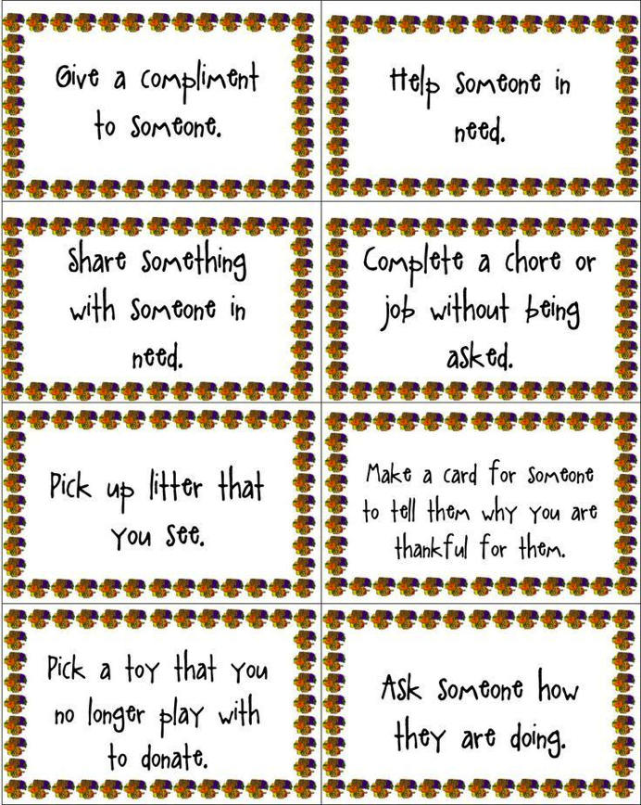
L.O. Can you use place value to solve these number problems? Year 3.

Use 64, 67 and 131 to make 2 adding and 2 subtracting sums.

+ ____ = + ___ = -___ = - ____ =

Now use + or – to find missing numbers.

54 - __ = 17 (think 54 - 17 = ___) 63 - __ = 37 (think - = ___)

___ + 53 = 100 (think - = ___) ___ - 28 = 13 (think + = ___)

Now use the inverse to find missing numbers.

I think of a number then subtract 5 and add 3. I now have 10. What did I start with?
___ - 5 + 3 = 10 (think 10 – 5 + 3 = ___ )

I think of a number then subtract 9 and add 7. I now have 15. What did I start with?
___ - 9 + 7 = 15 (think 15 – 7 + 9 = ___ )

I think of a number then subtract 13 and add 8. I now have 20. What did I start with?
___ - 13 + 8 = 20 (think 20 – 8 + 13 = ___ )

I think of a number then subtract 16 and add 12. I now have 25. What did I start with?
___ - 16 + 12 = 25 (think 25 – 12 + 16 = ___ )

Add 100 to each of these numbers.

19= 254= 605= 7= 389= 703=

Round each number to the nearest 100 to find the best estimated answer.

803 – 176 = ___00 - __00 = 632 + 478 = ___00 - __00 =

714 – 257 = ___00 - __00 = 863 + 379 = ___00 - __00 =

Use column addition and column subtraction to solve these money problems.
Ben buys crisps (55p), a drink (70p) and some sweets (£1. 20). What change does he get from £5?

Erin buys crisps (32p), a drink (68p) and some sweets (£2. 30). What change does she get from £5?

L.O. What multiplication facts do you know? Year 3

Double the 2x to find 4x then double again for 8x. Circle answers in both.

4, , , , , , , , , , ,48

8, , , , , , , , , , ,96

Double the 3x to find 6x. Circle answers in both.

3, , , , , , , , , , ,36

6, , , , , , , , , , ,72

Use the facts to find the product (multiply).

3 x 6 = __ = 8 x 12 ___ x 4 = 28 9 x 3 =

12 x 6 = 6 x __ = 3 x 8 __ x 8 = 42 + 6 5 + 9 + 6 = 5 x ___

Use the grid method to find out 25 x 5, 32 x 3, 64 x 4.
20+5
x5 100+ 25 =

Practise more sums using the grid method if you need to.
Circle the answer that is the odd one out. (Gives a different answer).

a. 2 x 5 x 4 5 x 8 20 x 2 12 x 5

b. 3 x 5 x 2 6 x 5 15 x 2 21 x 5

c. 7 x 5 x 4 7 x 20 35 x 4 21 x 5

Apples come in packs of 4 and banana in packs of 5.
Find the total if you buy 4 packs of apples and 3 packs of bananas.

Cakes come in packets of 10 and biscuits in packets of 12.
Find the total if you buy 5 packs of cakes and 5 packs of biscuits.
Have fun colouring this picture of our beautiful world. Can you draw your own?

