Class 6H – w/c 11th May 2020

Hello, everyone! It was really lovely to speak to you on the telephone – and your mum’s and dad’s. I am really pleased that everyone is keeping well – and busy! You have all been doing some amazing activities at home and sharing some fantastic family time! I am quite jealous living on my own!! I hope that you all managed to celebrate VE Day in some way too – I remember visiting London for the 50th anniversary of VE Day as a child – I went to a special event in Hyde Park and was able to see Princess Diana!

I know that lots of you are missing your friends – and even school! Don’t worry – this isn’t for ever and hopefully we will be able to see each other properly very soon! When we do eventually return to school (and I am hoping that it will be this school year!!), I have got lots planned with Mrs. Errington for you to enjoy your final bit of Year 6 and Primary School! I will be asking you all to bring in just three pieces of work/activities that you have completed whilst we have not been in school – the work doesn’t have to be things that I have set – it could be anything! I would like you to share this work with the rest of the class so that we can celebrate your achievements together! So… do start thinking about what you might like to bring in – it could be a photograph of an activity you did, art work, a written project… anything! But the aim is to make the rest of the class – and Mrs. Errington and I – say ‘wow’!

Don’t forget to prepare your entries for the photography competition – there’s a reminder of the categories if you look back at the Block 1 work set. Also, keep working on your book reviews and aiming to complete your reading passport. If you are able to present some amazing, detailed book reviews that I can put on display, I would love to have them! Feel free to email them to me via enquiries@cranwell.lincs.sch.uk or to just bring them in when we return. 7

Take care, stay safe and I look forward to seeing you all very soon.

Miss Hill xx

Many of you have completed much of the printed work I have set. If you would like something similar, try the link below – you can download and print a question book – and an answer book. There are some interesting tasks within it.

https://mailchi.mp/f8ef57bbb997/free-booklets-for-ks1-and-ks2?utm_source=All+Subscribers&utm_campaign=a8cc991fa1-EMAIL_CAMPAIGN_2019_06_28_10_39_COPY_01&utm_medium=email&utm_term=0_76ba1113bb-a8cc991fa1-74148905

For each week day, I would much prefer you to only do a bit every day and do it really well, rather than 6 hours of not very good work! Try to structure your day so that you have a good mix of activities – rest, food, exercise, play/fun, school work, reading for pleasure, electronics/TV time, sleep, etc.

I suggest each day that you spend:
One hour on literacy
One hour on numeracy
One hour on topic work

Please continue to complete your daily maths lesson, using the White Rose resources from the website. There may or may not be a sheet available each day this week (they keep changing their minds!), but if not, just have a go at the questions on the video, on a piece of paper. Remember to also follow the links to BBC Bitesize for even more practise.  You can find your lessons here:  https://whiterosemaths.com/homelearning/year-6/  Please move onto the section labelled ‘Summer Term Week 4 w/c 11th May’ & ‘Summer Term Week 5 w/c 18th May’ The videos are also available on Facebook, if the website is overloaded.  Of course, I’ll continue to set tasks on Mathletics, but only do these if you have spare time!  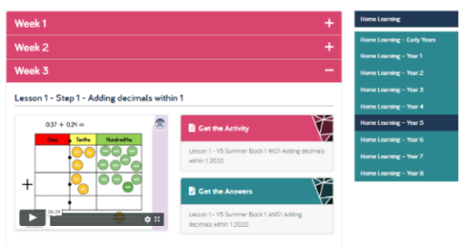 | Spelling Challenge – Have a go at the spelling booklet, which I have added to the end of this document. It should be revision! If you are not able to print, you can complete many of the activities by copying from the screen. Why not make flash cards for the words you find the trickiest? There are ten days of activities.  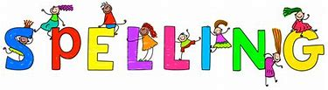 | Have a go at learning some more German using Duo lingo – make sure that you ask the adults at home for permission to access this.  https://www.duolingo.com/
HISTORY/WRITING TASK ONE: We’ll will continue to explore the history of inventions and innovations, moving forward on our timeline to the period between 1066 to just before the reign of Queen Victoria.  This week, I’d like you choose one of the following topics to research and write about:  - Charles Babbage’s computer  - Edward Jenner and the first vaccine  - George Stephenson and the railways  Write a biography about one of the famous people above. Remember to include lots of detail about their discovery/invention.  See the biography planning template below to help | HISTORY/WRITNG TASK TWO: The Victorian era was a golden age of science and innovation, when many of the devices we take for granted today were invented. I’d like you to do some research, choose the innovation or invention that you think was the most interesting, and write a short non-chronological report about it.  Here are some useful websites:  http://www.primaryhomeworkhelp.co.uk/victorians/inventiotimeline.html  https://www.bbc.co.uk/bitesize/clips/zhwqxnb  https://kidskonnect.com/history/victorian-inventions/  MINI TASKS:  1. Read about the different inventions; decide which one you like best.  2. Research the invention and the inventor in detail; make notes.  3. Draft your report, remembering to use subheadings and paragraphs.  4. Edit and improve your report; ask an adult to check it makes sense. Have you included your writing target?  5. Write up your report in your very best handwriting (no typing for this!). Make sure you show me the handwriting which earned you your Pen Award!  See the non-chronological report planning template below to help | https://www.dyson.co.uk/newsroom/overview/update/top-five-engineering-challenges-to-do-at-home.html?utm_campaign=uk_en__oe__na__s__discover_jdf_challenge_cards_family_event__awareness____multi_multi-Split_2&utm_source=Selligent&utm_medium=email&utm_content=10604BB429CC1EE791F53A9FE9E2805A__2001__498625__131001__16853220__330720  Explore Dyson’s engineering challenges – the top five and the full list of 44. Pick one or two that take your fancy to have a go at.
In the second of these two weeks, we should have had Grandparents’ Day, but sadly that can’t happen this year. So this week, as an extra activity, I’d really like you to make contact with your Grandparents, if you can. Have a chat with Mum and Dad about how to do this: you could phone them, use Skype, Zoom or an app on a phone perhaps. If they aren’t technologically-minded, they might really appreciate a letter or a picture through the post. You’ll probably have lots to talk about, but you might like to ask them about your family tree – who were their grandparents? If you don’t have grandparents to talk to, don’t worry – perhaps you could get in touch with other relatives, who I’m sure will also be really delighted to hear from you.  ! | Obstacle Course  You can never go wrong with an obstacle course, and they're a great way to improve coordination and motor skills. Set up a course all around the house with a range of different activities and motions, from throwing ping pong balls into a bucket to collecting Lego bricks along the way. The best part? It can be set up entirely indoors if it's a rainy day.  Fancy a change from Joe & Rosie Wicks? Every weekday morning at 11am, Ollie from The Beat Goes On is running live body percussion workshops on YouTube.  https://www.youtube.com/user/OllieTunmer/videos  PE – It’s really important that we all stay fit and active. Try to do at least an hour of playing in the garden or walking out with a parent every day. Fresh air makes us all feel better! If you’re stuck inside, try a Joe Wicks workout:  https://www.youtube.com/watch?v=-TGEdzRzSbw  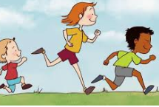 | Remember to read for pleasure daily.  Work towards completing your reading passport.  If you are running out of books at home, you can use the book on: https://www.twinkl.co.uk/home-learning-hub (Guided Reading) or try Oxford Owl’s free online library https://www.oxfordowl.co.uk/for-home/find-a-book/library-page which has lots of your favourites from school!
- You might like to explore - https://litfilmfest.com/resources/the-quick-fire-write-ks2/
The Quick-Fire Write challenges you to write around 200 words based on the 4 questions at the end of each video, around 50 words per question!
- You could also go online and use Education City, Mathletics, Timestable Rockstars, etc.
- You might be interested….on weekday mornings, Pie Corbett presents a free, creative and interactive literacy show called RadioBlogging at 9.30am. The hour-long show teaches writing and children can post their own writing online and receive feedback. https://radioblogging.net/
- You might like to create your own recipe book. Think about your favourite meals and snacks that your mum, dad and other family members make for you. Find out how to make them and then write down the recipes neatly and carefully. Decorate each recipe page and then stick them together. Make a front and back cover and then present it to someone you care about. They will be pleased to see the recipes they make for you featuring in your all-time-favourites book. Perhaps you could bake a cake or make some scones and then share your results with your grandparents, including the recipe in your super recipe book.
- You might like to ask an adult to show you how to do something practical that they enjoy doing – you could ask an adult at home, or with your parents’ permission, skype/Facetime/contact another adult – family or friend. Some suggestions:
- How to mend a puncture
- How to sew on a button
- How to knit or chochet
- How to plant some seeds
- How to make scrambled eggs on toast
- How to make bread
Remember to choose a good time to ask the adults in your home – not when they are tryng to do their own work!

Text Type: | Biography RH VERSION
Purpose: | To tell the life story of a famous or important person.
Text Features: | Written in the past or present tense: (was, did, had or is, does, has).  Written in the third person: (he, she, they)  Setting, early life, why they are important, conclusion.
Openers: | To signal time and sequence: He was born in..., He grew up with..., It was a time when..., At first..., After this…, Eventually…, Later in life…, He became...  Opinion: He is regarded by many to be…, It could be argued , Some believe…  Contrast and comparison: However..., Despite this..., Also..., This may seem...,  Conclusion and summary: It is thanks to..., The fact that..., Even today...
Vocabulary: | influential, significant, talented, gifted, famous, infamous, popular, respected, pioneered, invented, discovered, ambitious, determined, unique, remembered

Title:
Paragraph 1: Introduction

- Name of the person
- Profession/job
- Why they are a significant person

- Write about events in the order that they actually happened – chronological order.
- Concentrate on the most interesting events in their life.

Paragraph 2: Early life

- Use subheadings.
- A paragraph about the person’s childhood and early life
- When and where they were born
- The time in which he/she lived

Paragraph 3: First important event

- Use subheadings
- A paragraph which describes the first important thing they did or what made them famous.
- A few well-chosen quotes.
- Include some thoughts and feelings for the person.

Paragraph 4: Second important event

- Use subheadings
- A paragraph which describes the second important thing they did or what made them more famous.
- A few well-chosen quotes.
- Include some thoughts and feelings for the person.

Paragraph 5: Conclusion

- When and how did they die?
- Why was the person important?
- What impact did they have?
- What is their legacy, what have they left behind?
- Why/how will they be remembered?
- Aim to link the end back to the start.

Text Type: | Non-Chronological Report RH VERSION
Purpose: | To organise and record factual information, to inform the reader.
Text Features: | Written in the third person: (he, she, it, they)  Written in the past or usually the present tense: (was, did, had or is, does, has).  Non-chronological order, clear factual style  Heading, opening statement, sub headings with each paragraph  Formal and impersonal
Organisational Features: | Possible use of: bullet points, different font sizes, tables, diagrams, photographs, pictures, maps, to add more information, provide clarity and break up the text  Sub headings for paragraphs
Openers: | Most ..., Many..., Often..., They are..., They were..., They also..., It is…
Connectives: | Connectives, such as also, another, for example, in order to, so that, that, first, secondly.  Quantity: none, some, most, all, few, many, the majority of  Cause and effect: because, as a result, consequently, therefore, since, until, whenever, depending upon, eventually, subsequently  Comparison: equally, similarly, compared with, in the same way  Contrast: but, however, alternatively, the opposite, instead, apart from, yet, in contrast, nevertheless
Vocabulary: | Use and explain some technical and specialist words found during research:

1.Heading saying what the report is about:

Paragraph 1 with sub-heading – saying what the paragraph is about

Paragraph 2 with sub-heading – saying what the paragraph is about

Paragraph 3 with sub-heading – saying what the paragraph is about

Paragraph 4 with sub-heading – saying what the paragraph is about

Paragraph 5 - A concluding paragraph summarising the key points made – the main things that you want them to remember.

Aim to link the end back to the start.

Year 5 and 6 Spelling Booklet
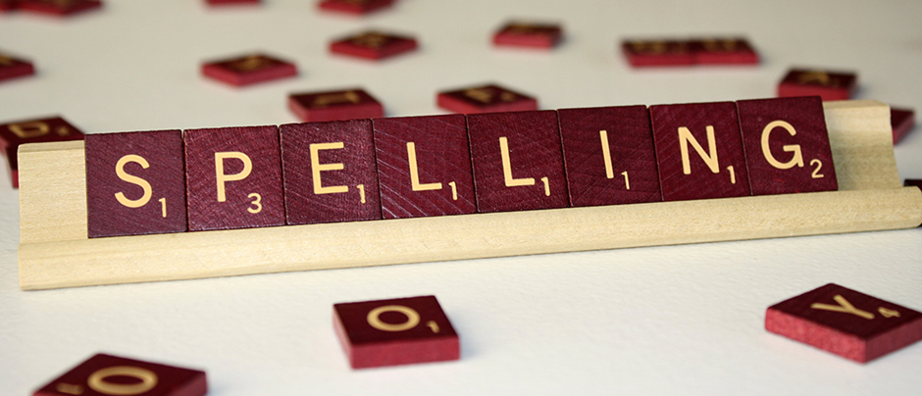

Weeks 1 and 2
Contents

Pages 2, 3 and 4 - words that are often confused
Pages 5 and 6 – words that are often confused
Pages 7 and 8 – silent letters
Pages 9 and 10 – ‘ough’ words
Pages 11 and 12 – words ending with –able and –ible / -ably and –ibly
Pages 13 and 14 – words ending with –cious and –tious
Pages 15 and 16 – words from the Year 5/6 Statutory Spelling List
Pages 17 and 18 – words from the Year 5/6 Statutory Spelling List
Pages 19 and 20 – words from the Year 5/6 Statutory Spelling List
Pages 21 and 22 - words from the Year 5/6 Statutory Spelling List

Words that are often confused
DAY ONE

two / to / too
- two is a number.
- to means toward.
- too means also, much, or very.

their / there / they're
- their shows possession.
- there is a place.
- they're is a contraction for they are.

its / it’s
- its shows possession
- it's is a contraction for it is.

your / you’re
- your shows possession.
- you're is a contraction for you are.

by / buy / bye
- by means near or beside.
- buy means to purchase.
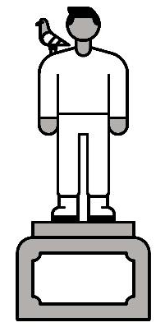
- bye is a shortened form of goodbye.

stationary / stationery
- stationary means standing still.
- stationery means paper to write on.

affect / effect
- affect is a verb meaning to influence.
- effect is a noun meaning result.

council / counsel
- council is a group that makes decisions together.
- counsel is a verb meaning advise.

lose / loose
- lose means to not win or you can't find something.
- loose means roomy or unrestrained.

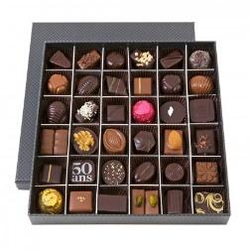
Can you fill in the blanks with the correct word?

two / to / too
There were ________ many chocolates in the box to count!
I need _______ socks to make a pair.
I went _______ the cinema for my birthday.
their / there / they're
___________ are no pencils left in the tray.
They are painting __________ house today.
I would love to visit the theme park that _____________ visiting.
its / it’s
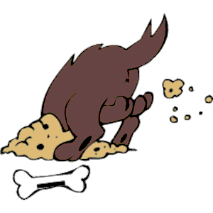
The dog is going to bury _______ bone.
________ going to be cloudy and rainy today.
your / you’re
___________ going to enjoy this football match.
“I like __________ trainers,” said Michael.
by / buy / bye
He waved his hand to say _______ to his friends.
I would love to _______ a new car.
She has walked ______ my house several times today.

Fantastic work!
Can you read this story? Underline the words that have been spelled incorrectly and highlight the words that have been spelled correctly.
We’d nearly run out of paper, so Miss Smith had to fill in a stationery order. She had promised that the School Counsel could use some of it at there meeting. She hoped that they wouldn’t lose any of it! That would have a terrible effect on the art activities she had planned for tomorrow. They’re wouldn’t be enough paper and too many children would have two share.
Can you write a short story / sentences that include some of the spellings you have learned today?

DAY TWO
Words that are often confused

Can you find the definitions for these words that are often confused? Some of the words may have more than one definition!

Word | Definition
morning
mourning
past
passed
led
lead
isle
aisle
aloud
allowed
desert
dessert

Can you now write the word that matches the picture?
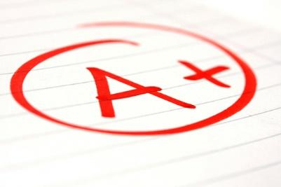
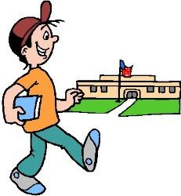

_____________________
_____________________
_____________________

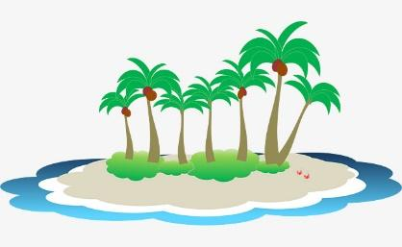

_____________________
_____________________

_____________________
_____________________

Correct or Incorrect? Tick or cross!
The desert was dry and sandy.
I read the story allowed.
She walked passed the shop.
The supermarket aisle was very busy.

No drinks were aloud in the shop.
In the morning, I ate breakfast.
I past the exam with flying colours!
The couple walked down the isle.

Silent Letters
DAY THREE

Can you read these words correctly?
A silent b occurs after m, before t – lamb, bomb, thumb, debt…
A silent k and a silent g are found before n – gnome, gnat, knee, knife…
A silent l follows vowels a, o, u – calf, salmon, chalk, yolk…
A silent w often goes before r – wrapper, wrestle, wrist, wreck…
Can you find the ‘silent letter’ words that match the pictures?
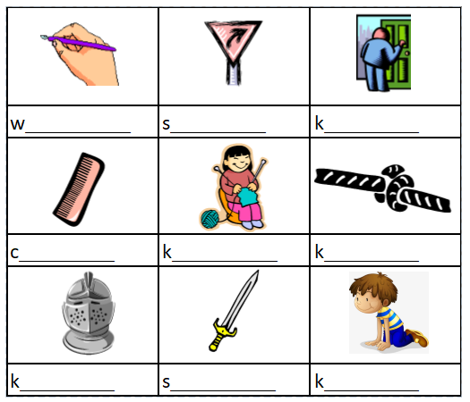

Here are some more ‘silent letter’ words. Can you read them aloud?
Ache
Guilt
Handkerchief
Hymn
Knee
Know
Listen
Numb

Psychology
Scene
Scissors
Sword
Technology
Tomb
Whistle

Autumn
Chemical
Column
Crescent
Echo
Foreign

Ask a family member to choose 10 ‘silent letter’ spellings to test you on.

Final task today! Can you underline all of the ‘silent letters’?

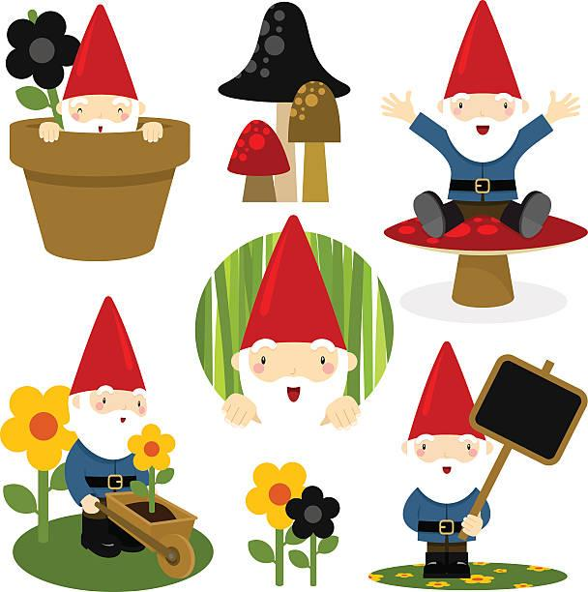
There must be a knight wearing knickers in a tomb. Surely that must be wrong, so I asked the whale. He was honest and he answered only half my question, then knocked me over with the splash of his tail. Shall I wait until Christmas? No, I’ll ask the folk with the lambs and the wriggling swords. They were useless, but they pointed me in the direction of the gnomes. The gnomes, who waited in the garden, fishing by the pond, whispered the answer in my ear.
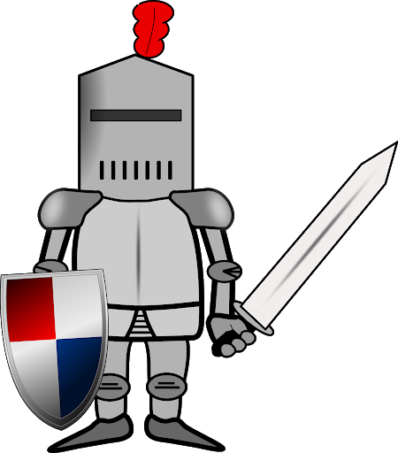

ought, bought, thought, nought, brought, fought, rough, tough, enough, cough, though, although, dough, doughnut, through, thorough, borough, plough, bough, drought
Can you sort these ‘ough’ words by their sounds?

off | uff | aw | o | oo | ow | u

The ‘ough’ sound
DAY FOUR

Now find the words that fill the gaps in the sentences.

He ______________ very hard in the boxing match.
You need _____________ to make bread.
I _________________ the ingredients to make a cake.
The oven was quite dirty, so I gave it a ___________________ clean.
The farmer uses his ______________ on his field.
I _____________ to try and exercise more.

Word Search
d | y | h | e | r | s | t | b | t | h | g | u | o | n
t | b | m | n | r | q | z | v | l | k | o | u | w | p
r | w | e | b | o | u | g | h | t | r | t | f | j | l
o | r | v | t | u | n | m | c | o | t | h | u | o | j
u | z | e | r | g | r | y | u | u | i | o | f | k | l
g | w | r | t | h | s | n | b | g | x | u | z | e | t
h | t | h | g | u | o | f | r | h | k | g | g | h | h
d | y | u | m | v | d | s | s | l | r | h | t | p | g
l | h | g | u | o | h | t | l | a | o | t | o | q | u
a | a | d | e | k | k | s | y | t | r | e | w | q | o
a | g | t | d | o | u | g | h | h | j | k | v | f | r
z | d | g | j | h | g | u | o | r | o | b | j | k | d

bought drought although thought tough borough nought rough fought trough dough

Find the words in the sentences that rhyme with the ‘ough’ word.
Although there was a snow storm, the children still wanted to go outside in the garden.
The baker kneads the dough so that when the bread is cooked it will have a light airy texture.
It was tough luck that we hadn’t got the right sort of stuff with us to make a shelter in the
woods when it started to rain.
The cat wanted to get through the door so that it could chew my shoe.
Luckily when the sea got rough we had enough life jackets for everyone on board the boat.
All the children brought their shorts to school to wear for Sports Day.

Words ending with –able and –ible / -ably and -ibly
DAY FIVE

Can you identify the correct and incorrect spellings?

horrible | flexible | arguible | changeable | available | noticeable | flexable | terrable
arguable | changeible | laughable | noticeable | laughible | horrable | availible | terrible

Correct:

Incorrect:

Can you unscramble these anagrams? Remember, the –able/–ably endings are far more common than the –ible/–ibly endings. Choose your answers from the words below.
adorable adorably applicable applicably considerable considerably
tolerable tolerably legible legibly horrible horribly
- gebyill
- paialceblp
- otelarlbe
- hroirlbeo
- ocnisedarlby
- darobael
- noisdcearlbe

Word Search
d | u | j | a | d | a | p | t | a | b | l | e | l | g | l | e
v | b | f | u | u | k | a | y | k | e | l | g | x | c | d | x
q | a | d | d | f | h | u | k | n | l | x | v | y | u | e | c
i | b | m | i | t | s | r | y | g | i | f | l | s | w | l | i
w | s | t | b | b | n | m | z | d | e | r | i | y | r | b | t
r | k | f | l | b | w | r | y | l | v | x | r | e | w | i | a
c | e | q | e | r | t | u | i | o | a | h | k | d | r | t | b
a | l | t | r | y | u | g | u | k | b | d | f | w | t | r | l
p | b | g | y | u | k | x | c | v | l | b | n | m | e | e | e
a | a | m | o | p | p | a | s | s | e | d | x | c | l | v | t
b | s | e | n | s | i | b | l | e | q | p | g | t | b | n | r
l | o | x | h | g | h | j | k | l | w | r | t | x | a | o | l
e | p | k | k | a | v | b | d | s | h | j | k | u | t | c | e
e | s | d | i | g | e | s | t | i | b | l | e | e | i | o | p
a | i | f | i | n | v | i | n | c | i | b | l | e | u | a | t
s | d | r | m | a | n | r | a | p | e | l | b | i | s | i | v

adaptable believable visible capable suitable digestible disposable audible sensible excitable convertible invincible

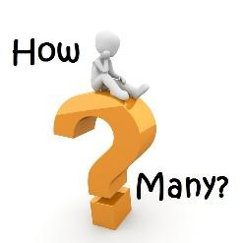
How many other –able and –ible words can you find? Can you add the ‘ably and –ibly endings to them?

-able | -ably | -ible | -ibly

Words ending with –cious and –tious
DAY SIX

Sometimes a root word will give you a clue which spelling to choose:
- Words ending in –tion change to tious – ambition/ ambitious
- Words ending in –ce change to –cious – grace / gracious
cautious infectious nutritious pretentious fictitious superstitious
conscious precious vicious gracious ferocious delicious suspicious spacious

Can you use the words above to complete these sentences?
I was ______________ of the time – I was running late.
You have to be ______________ when using tools.
This room is very ________________; I could fit 3 sofas in it!
The story he told me was ___________________, as it was all made up.
The detective was __________________ of the criminal.
That cake is very ___________________, but not very __________________.
My necklace is _______________, so I keep it in a box.

Watch this BBC Bitesize video!
https://www.bbc.co.uk/bitesize/topics/zt62mnb/articles/zp7dk7h

Add –tious to turn these nouns into adjectives!
- ambition
- caution
- contention
- expedition
- nutrition
- repetition
- superstition

Add –cious to turn these nouns into adjectives!
- office
- space
- grace
- malice
- vice

Most words ending with the ‘shus’ sound are spelt –cious.
Can you add –cious to each of these word beginnings and then find out what they mean?
auda___________
atro____________
offi_____________
auspi___________
vora____________
capa____________
pre_____________
gra_____________

Words from the Year 5/6 Statutory Spelling List
DAY SEVEN
accommodate accompany
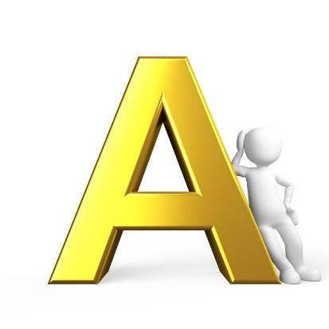
according achieve
aggressive amateur
ancient apparent
appreciate attached
available average
awkward

Some challenges for you!
Look at one of the words for 10 seconds. Close your eyes/look away and answer the following questions:
- How many letters does the word have?
- How many vowels does it have?
- Which vowels are in the word? Not in the word?
- How many consonants in the word?
- Which consonants are in the word? Not in the word?
- How many letters with descenders? Ascenders?
- Which letter is first alphabetically? Last?
- Write it on a piece of paper!
- Spell it backwards on your piece of paper!

Repeat for each spelling! How many could you remember?

Caption It!
Write a caption underneath each picture below, using as many of the words as possible!

accommodate accompany awkward
according achieve
aggressive amateur
ancient apparent
appreciate attached
available average

Words from the Year 5/6 Statutory Spelling List
DAY EIGHT

bargain bruise
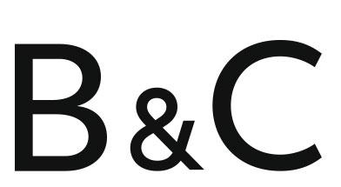
category cemetery
committee communicate
community competition
conscience conscious
controversy convenience

Some challenges for you!
Look at one of the words for 10 seconds. Close your eyes/look away and answer the following questions:
- How many letters does the word have?
- How many vowels does it have? How many consonants?
- Are there any repeated letters in the word? How many?
- What is the second letter? The fourth letter? The last letter?
- Can you put the letters in alphabetical order?
- Write it on a piece of paper!
- Spell it backwards on your piece of paper!
- Write it in capital letters!

Repeat for each spelling! How many could you remember?

Work out the value of each word.
A = 1
B = 2
C = 3
D = 4
E = 5
F = 6
G = 7
H = 8
I = 9
J = 10
K = 11
L = 12
M = 13
N = 14
O = 15
P = 16
Q = 17
R = 18
S = 19
T = 20
U = 21
V = 22
W = 23
X = 24
Y = 25
Z = 26
WORD | VALUE
bargain | 2 + 1 + 18 + 7 + 1 + 9 + 14 = 52
bruise
category
cemetery
committee
communicate
community
competition
conscience
conscious
controversy
convenience

Which is the most ‘valuable’ word? Was it the one you expected it to be?

Words from the Year 5/6 Statutory Spelling List

DAY NINE

correspond criticise
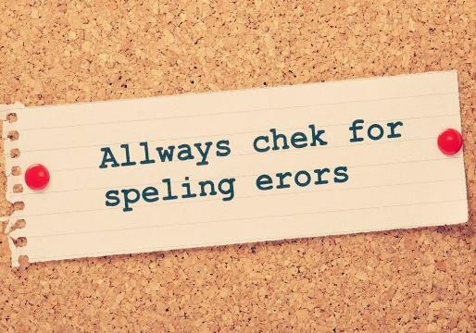
curiosity definite
desperate determined
develop dictionary
disastrous embarrass
environment equipment

Some challenges for you!
Look at one of the words for 10 seconds. Close your eyes/look away and answer the following questions:
- How many letters does the word have?
- How many vowels does it have?
- Which vowels are in the word? Not in the word?
- How many consonants in the word?
- Which consonants are in the word? Not in the word?
- How many letters with descenders? Ascenders?
- Which letter is first alphabetically? Last?
- Write it on a piece of paper!
- Spell it backwards on your piece of paper!

Repeat for each spelling! How many could you remember?

Word Search
s | u | o | r | t | s | a | s | i | d | d | s
a | f | g | j | k | j | l | t | e | s | d | d
a | y | t | i | s | o | i | r | u | c | f | e
c | v | b | n | f | h | j | k | w | o | s | t
t | n | e | m | p | i | u | q | e | r | s | e
r | t | d | q | p | o | c | x | s | r | a | r
d | e | s | p | e | r | a | t | e | e | r | m
a | w | f | h | k | n | v | x | g | s | r | i
p | o | l | e | v | e | d | p | u | p | a | n
i | i | w | h | l | e | e | l | k | o | b | e
a | s | d | c | v | m | n | t | t | n | m | d
a | l | e | t | i | n | i | f | e | d | e | i
c | d | i | c | t | i | o | n | a | r | y | c
e | n | v | i | r | o | n | m | e | n | t | p
t | y | o | e | s | i | c | i | t | i | r | c

correspond criticise curiosity definite desperate determined develop dictionary disastrous embarrass environment equipment

Match the picture to the spelling!

_________________________
_________________________
_________________________
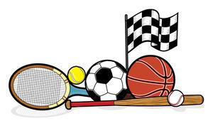

_________________________
_________________________

Words from the Year 5/6 Statutory Spelling List
DAY TEN

especially exaggerate
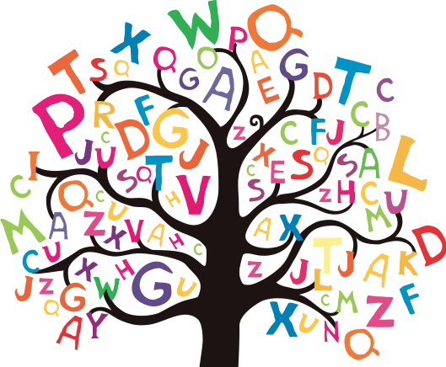
excellent existence
explanation familiar
foreign forty
frequently government
guarantee harass

Some challenges for you!
Look at one of the words for 10 seconds. Close your eyes/look away and answer the following questions:
- How many letters does the word have?
- How many vowels does it have? How many consonants?
- Are there any repeated letters in the word? How many?
- What is the second letter? The fourth letter? The last letter?
- Can you put the letters in alphabetical order?
- Write it on a piece of paper!
- Spell it backwards on your piece of paper!
- Write it in capital letters!

Repeat for each spelling! How many could you remember?

Can you unscramble these anagrams?

- Ogevnremtn
- ceelxenlt
- oefrgin
- seeypiclla
- npaaxitloen
- autnrgeea

especially exaggerate excellent existence explanation familiar foreign forty frequently government guarantee harass

Synonyms
Can you think of the synonyms for these words, from today’s spelling list?

- often
- well-known
- promise
- distant
- description
- brilliant
- pester
- life

