Dear children and parents

Here we go…another week of home learning! It was lovely to speak to most of you last week (as I write) and to hear all about the great work and creative activities you’ve been doing at home. I’m pleased to be able to tell you that all your friends are OK . Some of you are EVEN looking forwards to getting back to school!!! Mrs Barrett and I have been working hard, getting things ready for whenever that will be. I have slightly fewer weeds in my garden this week, I’m glad to say, as well as two new, tiny trees that I bought (mail order) from the Woodland Trust – more of that later. Mrs Barrett has been having fun swimming in her paddling pool and dressing up in fancy dress costumes (you know how amazing her costumes are!) to keep her spirits up. Well, the good news is that this week should have been your week for lots of horrid tests, so at least you’ve escaped those – that’s a good reason to be cheerful! So keep up the great work and remember that you can contact me, through school reception (01400 659001), if you have any questions about the work I’ve set or if you need help with anything else.

Mrs Bullement
Maths  Please continue to complete your daily maths lesson, using the White Rose resources from the website. There may or may not be a sheet available each day this week (they keep changing their minds!), but if not, just have a go at the questions on the video, on a piece of paper. Remember to also follow the links to BBC Bitesize for even more practise.  You can find your lessons here: https://whiterosemaths.com/homelearning/year-5/ Please move onto the section labelled ‘Summer Term Week 4 w/c 11th May’. The videos are also available on Facebook, if the website is overloaded.  Of course, I’ll continue to set tasks on Mathletics, but only do these if you have spare time!  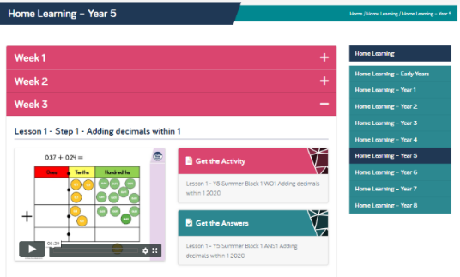  Want an extra challenge? Have a go at the two puzzles below – they should get your brain working! Perhaps you could phone a friend and compare answers? See if you can explain your reasoning to Mum or Dad too. | English  I thought you’ve like to have a go at some creative writing this week, for a change. I found a great piece of fiction about ‘Fantastic Beasts and Where to Find Them’ in my newspaper and have attached it below. The task is to have a go at continuing the story… Remember our method (perhaps do one step each day):  - Read the story carefully.  - Think what you’d like to happen next – where will you take your part of the story?  - Write some notes into a plan – you might like to use a story mountain, cartoon strip or just write notes in order.  - Draft your story.  - Write it up in your best handwriting to share with someone in your family.  Things to check:  - Does it make sense?  - Does every sentence start with a capital letter and end with .?! or …  - Have you used a new paragraph when the person, place or time changes, and for speech?  - Have you included your writing target?  Art  Inspired by your story, can you draw or paint an fantastic illustration?
SPAG  A sheet to do this week! I’ve included a sheet at the end of this document for you to have a go at. It’s one of our ‘Grammar Hammers’ and revises lots of the work we’ve covered so far. | 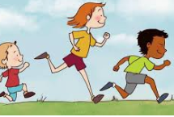  PE  It’s really important that we all stay fit and active. Try to do at least an hour of playing in the garden or walking out with a parent every day. Fresh air makes us all feel better! If you’re stuck inside, try a Joe Wicks workout:  https://www.youtube.com/watch?v=-TGEdzRzSbw  Alternatively, how about a bit of yoga? Have a look at the great stories on https://www.cosmickids.com/ and remember to save time for a ‘Peace Out’ at the end!
Reading
Please make sure you read for at least 20 mins every day this week. If you don’t have a book at home, you can use the book on: https://www.twinkl.co.uk/home-learning-hub (Guided Reading) or try Oxford Owl’s free online library https://www.oxfordowl.co.uk/for-home/find-a-book/library-page which has lots of your favourites from school!
French
I’m really enjoying practising my French each day on Duolingo and I hope you are too! Keep that streak going!
https://www.duolingo.com/
Science – Earth and Space  I hope you enjoyed your star gazing and managed to spot some of the constellations from your sheet. This week, we’re learning about why we have night and day. Have a look at BBC Bitesize for a great explanation: https://www.bbc.co.uk/bitesize/clips/zkynvcw  There’s also a simple set of instructions for an activity to help you to understand, at the bottom of this document.  If it’s a sunny day, you can put all this to the test. Go out nice and early and put a stick into the ground. Where does its shadow lie? You could mark the end of the shadow with a stone. Go out at lunchtime and see what’s happened. Repeat your observation later in the afternoon. This is how a sundial works and here are some instructions to help you make your own: https://www.youtube.com/watch?v=Gxo8orZ1X7g | History  This week, we zoom forwards to the 20th Century. I’d like you to find out about the History of Computing, which is an innovation that changed our lives forever. You might like to watch: https://www.bbc.co.uk/bitesize/topics/zbhgjxs/articles/ztrq7ty. If you scroll down to the bottom of that webpage, you’ll find some other interesting activites to do with computers too.  I won’t ask you to write anything for History this week, as you’ll be busy with your fantastic story!
Other ideas for outside
I mentioned earlier that I had just planed two trees, or saplings, from the charity The Woodland Trust. They also have some super ideas of things to do in your back garden or when you’re out for a walk: https://www.woodlandtrust.org.uk/blog/2020/04/nature-activities-for-kids-to-do-at-home-part-4/ .
With very little traffic on the roads and few aircraft in the skies, we can hear the birds singing really clearly at the moment. If you’d like to be able to identify the birds from their songs, have a look the RSPB website: https://www.rspb.org.uk/birds-and-wildlife/bird-songs/what-bird-is-that/. Has anyone heard the cuckoo yet?

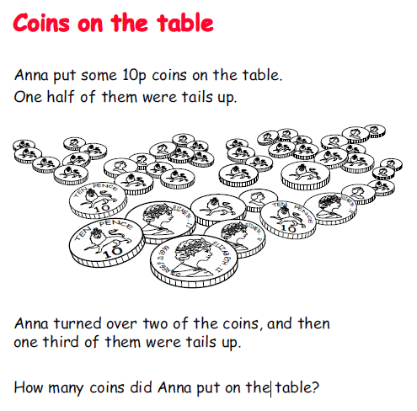
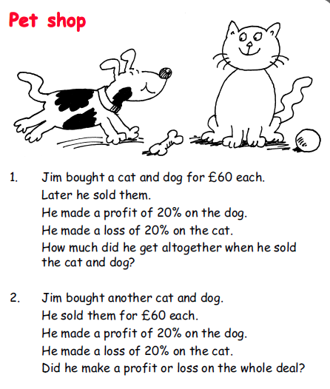

Reproduced from ‘Puzzles and Problems for Y5-6’, Crown Copyright.

Science: from Twinkl
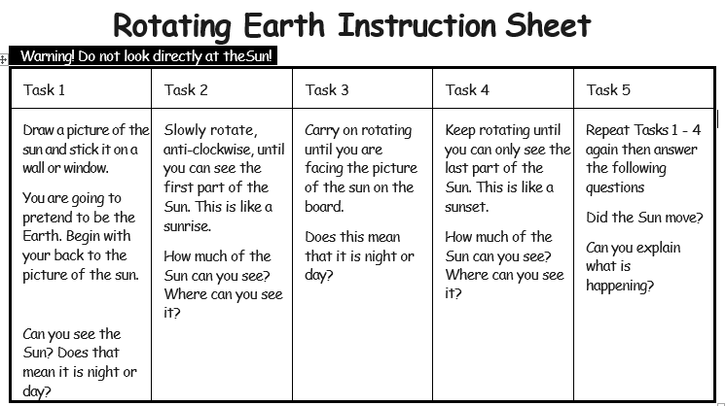

Stage 5 ‘Grammar Hammer’ Skill Check 5

Name: ______________________________________ Class: _________ Date: ______________

1. Underline the suffix that turns the noun into a verb. |  |  |  |  |  |  |  |  | 2. Underline the suffix that turns the noun into a verb.
final | ify |  |  |  |  | ize |  |  | dead | ate |  |  |  | en
3-4. Underline any silent letters in these words.
sign |  |  |  | poster |  |  |  |  | character |  |  | person
5-6. Underline the correct word to use in each sentence. Use a dictionary if you need to.
I will see you in the ( mourning / morning ). |  |  |  |  |  |  |  |  | I will need ( flour / flower ) to make bread.
7. Use a dictionary to find the meaning of this word.
plethora
8-9. Number these words to show their alphabetical order.
drink |  |  |  |  | drain |  |  | drip |  |  |  |  | drizzle

10-11. Underline two connectives that can be used to compare and contrast
fortunately | although |  | suddenly |  | also |  | despite this
12-13. Underline two sentence openers that might help show time and sequence in a piece of writing
Later, |  | However, |  | Afterwards, |  | Including,
14-15. Underline the correct verb tenses to complete the sentences.
I ( gave / give ) you a present last birthday. |  |  |  | Will you ( gave / give ) me one back?
16. Underline the correct verb to agree with the subject. |  |  |  | 17. Underline the correct verb to agree with the subject.
Class 6 ( was / were ) in the hall. |  |  |  | They ( was / were ) rehearsing their play.

18-19. Underline the correct verb to make these sentences correct.
Ben ( woke / woken ) up early. | The baby was ( woke / woken ) up.
20-21. Circle the adjective in this sentence and underline the expanded noun phrase.
Unfortunately, the poor dog didn’t enjoy the long, twisty, car journey.
22. Underline the correct modal verb to complete the sentence.
It is getting cold. You ( ought to / could / would ) put on a jumper.
23. Underline the relative clause in this sentence.
The lady, whose dog was barking, tried to calm it down.
24. Use a comma to punctuate this sentence and make the meaning clear.
When the dog barked the baby started to cry.
25. Punctuate this sentence with dashes - to show parenthesis.
Dan came home from work he is a plumber and made the tea.

Total: |  | Red (0 – 9) | Yellow (10 – 19) | Green (20 – 25)

★ ENGLISH
Creative writing (From The Sunday Times in conjunction with The Oak Academy)This passage is based on the film Fantastic Beasts and Where to Find Them, written and produced by JK Rowling.
As Newt Scamander explored the streets of New York, eager to discover what magical creatures awaited him, he marvelled at the sights: the skyscrapers peering down, the train passing overhead and the traffic honking its horns in angry protest. Suddenly, the hustle and bustle of a nearby crowd drew his attention towards the steep stone steps in front of a bank, where a woman was delivering a peculiar speech — about the supernatural — to the crowd.
From out of nowhere, Jacob Kowalski, who had an important meeting at the bank, approached the vast crowd but, as he did so, lost his footing and tripped over Newt’s identical leather suitcase, which was on the ground by his feet. Picking up the wrong suitcase, Kowalski hurriedly made his way through the crowd and up the steps towards the bank.
At the very top of the steps, a man leaving the bank flipped a coin, and, whether it was the sound of it as it bounced down the steps or the smell of the metal, who knows, something caught the Niffler’s attention! Razor-sharp, diminutive claws began to prise open the side of the case inside which he was concealed. Unable to resist anything shiny, the greedy Niffler escaped and scuttled behind a stone pillar. Newt caught a glimpse of a beggar’s hat being dragged off into the distance...
One shiny, valuable coin was not enough to satisfy the cute yet extremely greedy Niffler. The whiff of freshly polished coins hung in the air, luring the mischievous gold-digger. Scurrying furtively into the bank, the Niffler spotted a trolley containing several bags of money. Seconds later, Newt, who was desperate to find the cunning little money thief, entered the building. Suddenly, from out of nowhere, a deep voice bellowed across the room:
“Hey! Mr English guy, I think your egg is hatching!”
Jacob, who had realised the cases had been switched, had discovered the mysterious contents. What was going on? What was in the egg? Why had he become involved? Not wanting the whole world to know his secret, Newt quickly cast a spell, and suddenly their bodies twisted, egg and cases in hand. They were transported onto a deserted staircase. Transfixed by the cracking egg, they stared at what could only be described as a minuscule dragon, which had begun to poke its curious head out of the shell.
Out of the corner of his eye, Newt then noticed the Niffler disappear into a nearby vault. “Alohomora!” Newt commanded as he pointed his trusty wand in the direction of the vault.
In the blink of an eye, the vault started to open, while Jacob stood motionless, staring in disbelief.
Suddenly, a voice from behind boomed: “Oh, so you’re going to steal the money, are you?”
Without a moment of hesitation, Newt knew what to do: “Petrificus totalus!” he shouted, pointing his wand.
And with that, the bank employee froze like a cat caught in the headlights of an oncoming vehicle. Thud! He hit the floor with an almighty force.
Newt entered the vault after the naughty Niffler, who was sitting casually on one of the safety deposit boxes as if he were sunbathing on a beach. Newt scooped him up into his hands, like a claw in an amusement arcade machine, shook the Niffler and out tipped the treasures hidden away in the Niffler’s pouch. Without warning, the security guards could be heard charging down the stairs like a herd of angry elephants...
Your turn
Your task is to write the next part of the story, following on from the last sentence about the arrival of the security guards.
▶ What happens next?
▶ How do they escape the security guards?
Things to think about
▶ What does Newt do when he sees the security guards?
▶ How does he avoid being arrested?
▶ What does he say to Jacob or the security guards?
▶ Do Newt and Jacob leave the bank and go somewhere together? Or does Newt go off alone with the Niffler? Where do they go?
▶ Do they meet any other magical creatures? Where are these creatures? (Perhaps they live in a magical world inside the suitcase.)
▶ What do these other creatures look like?
Where do Newt and Jacob go next?
▶ Is there a mystery to solve?
▶ What other dilemmas might Newt encounter?
▶ How does he solve these problems?
Some sentences to get you going
“Stop what you’re doing and put your hands up!” shouted the head of security.
As quick as a flash, Newt simultaneously reached for the mischievous Niffler and the stunned Jacob while muttering a transportation spell.
Babbling in disbelief, Jacob began to back away from the bizarre events taking place in front of him.
Set by Lorraine Leonard, Lisa Cooke and Ben McGarry

