Maths
For the first week our maths topic is money. We have covered some aspects of money in class so use this to revise the topic.
The second week’s topic is multiplication and division.
Times tables
You need to keep practising your times tables. Have a look on the times table page for websites to help you.
Writing/Topic
Our history topic this term is a local study. We will be exploring the history behind RAF Cranwell. See the grid below for some project based ideas.

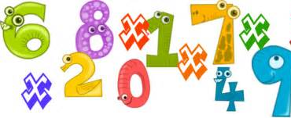

Extras – PSHE
I know at the minute things can feel a little uncertain and even overwhelming. But, during these difficult times, one thing is clear: small acts of kindness make a big difference.
Across the country, there has been an outpouring of kindness. The power of kindness calendar helps you learn about and carry out kind acts.
See the Extras page for more information

Reading
We would normally read every day in class – try to read every day and record this in your reading record.
See Reading page for an online comprehension task

Spelling Punctuation and Grammar
Use this time to learn the words from the 3/ 4 Word list you can find in the front of your planner.
Check out the SPaG page below for some more ideas.

Maths Activities
Well done for working through your recent maths activities. Please be careful which unit you are working on as we started a week behind on our fractions work. This work is to last you two weeks. The Money topic follows the same structure as before, there is a video for you to watch that goes through the learning objective for the day. Then there is an activity (pink button) for you to work through. You can either print these sheets out or do your working out in your homework book.
The Multiplication and division topic does not provide worksheets. There will be questions throughout the video for you to answer.
For more practise click the link to Bitesize daily lessons which are now linked to our White Rose Home Learning https://www.bbc.co.uk/bitesize/tags/zmyxxyc/year-3-and-p4-lessons/1
https://whiterosemaths.com/homelearning/year-3/

Week beg 11th : Please complete Summer term Week 3 - Money

Week beg 18th : Please complete Summer term Week 4 – Multiplication and division

For the end of the week or after each video/ activity I will include matching activities on Mathletics and Education City so that I can monitor who is completing the work and how much you are understanding it.
https://login.mathletics.com/ https://www.educationcity.com/

Please remember to log in to find the work I have set. If you have not completed the previous activities (I know who you are! ) please complete to keep you up to date with our maths topics.

Extra Maths Games
https://play.prodigygame.com/ - Pokemon style game with maths questions!
https://play.edshed.com/ - practise your number bonds, power of 10 and addition and subtraction
www.topmarks.co.uk –interactive games
https://www.oxfordowl.co.uk/for-home/kids-activities/fun-maths-games-and-activities/#maths-7-9 – games and activities
https://www.mathswithparents.com/KWeb?startTime=1584558592239#menu584883 – Free access to parents – videos and activities across the maths curriculum.

Times Table Activities

https://play.ttrockstars.com/auth/school - Times Table Rock Stars is a great way to practise your times tables
https://play.edshed.com/ - Practise your times tables
https://www.timestables.co.uk/ - Learn and practise
https://www.topmarks.co.uk/maths-games/7-11-years/times-tables
https://www.oxfordowl.co.uk/for-home/maths/help-with-times-tables/ -

Using the map of the UK on the next page, can you locate Cranwell? What county do we live in? Where is our closest city? What region do we live in? Can you name all other regions of the UK? Clue…. there are 12 regions altogether. You might like to use maps, atlases, books or the internet to help you research these questions.  History Activities |  | Using any resources you have at home, can you design and make a RAF aircraft?
Can you draw a map of your route you take to school? Try and include the key features of a map and the use of a key Think about what points of interest you pass on your journey. | Thinking about the history of RAF Cranwell, can you research the following street names and find out why they got their names:  - Airship Road  - Lighter-Than-Air Road  You might like to create a fact file or powerpoint to present your results. | 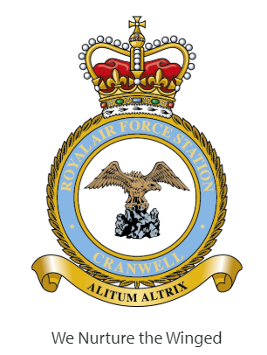  Using the RAF Cranwell station crest below as your inspiration, create your own family crest denoting a motto you abide by (try to find the Latin translation), and an animal that you think represents your personality. This might be a nice activity to discuss and work on together with your family.
RAF Cranwell plays an important part in a lot of our daily lives. Can you research the history and find any interesting facts about RAF Cranwell? You might like to make a presentation or poster to display your findings.
Can you design and draw a new, futuristic aeroplane that could be used within the RAF, considering all features an aircraft might need? | Where, when and how did the RAF begin? Can you find out all about the history of the RAF?  Present your findings how you wish.

Spelling Punctuation and Grammar Activities
R.E. Topic Work
https://play.edshed.com/ - I have assigned you all the spelling activities based on the spelling patterns we have already looked at this year as revision.
You have a list of words in your planner than you need to know by the end of Year 4. Learn some of these that you did not know before. Find them in a dictionary and write them in a sentence.

https://go.educationcity.com/ - Log in and select classwork to find a selection of SPaG activities to complete.

https://www.topmarks.co.uk/english-games/7-11-years/spelling-and-grammar - A selection of different games and activities to help you learn and practise SPaG topics.

https://www.bbc.co.uk/bitesize/dailylessons - If you want to extend your learning this is a great resource which may teach new concepts but also revisits previously learned material and is a great way to refresh your knowledge whilst on lockdown.

Reading
The Worst Witch by Jill Murphy
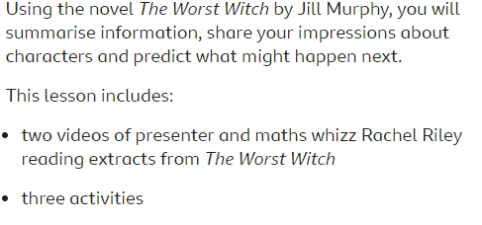
https://www.bbc.co.uk/bitesize/articles/zjk9kmn

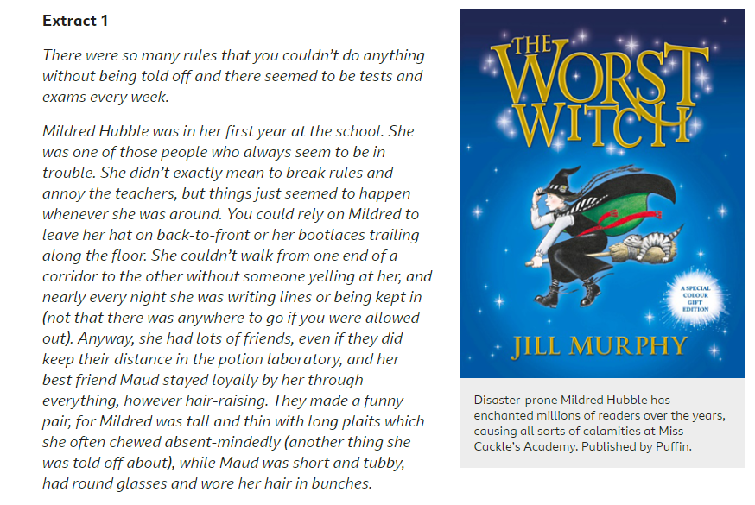

Extras!
Don’t forget you can play sports in your garden and have fun!
If you want some extra PE resources these are things we use in class;
https://www.cosmickids.com/ - Yoga
https://www.youtube.com/watch?v=gCzgc_RelBA – Just Dance
https://www.youtube.com/watch?v=mhHY8mOQ5eo – Joe Wicks Fitness video

